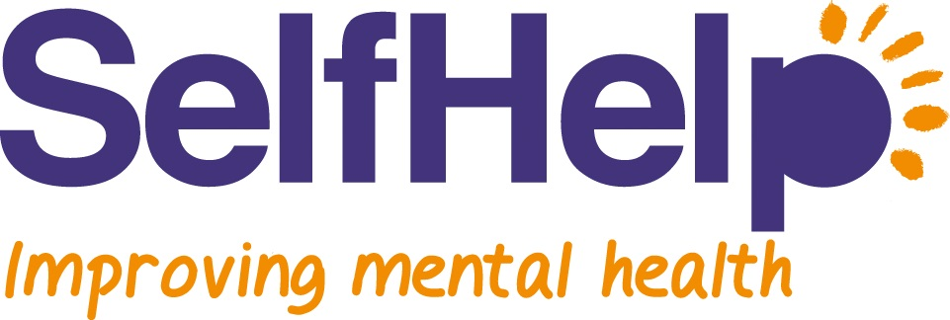

Your Information: how it is used and how to gain access to it
Introduction
Self Help complies with the Data Protection Act 1998 and the Confidentiality NHS Code of Practice. This means that everyone working for or on behalf of Self Help must respect your confidentiality. Any information, whether on electronic or paper records - including referral forms and clinical records – is private and personal and the process of collecting, storing and retrieving your information must be secure. You have the right to expect your personal information to be kept private. You also have rights to confidentiality under data protection, human rights legislation and the common law.

Why do we keep Information?

We keep information about you to enable us to provide safe and effective services, which meet both your needs and the needs of the community we serve. Therefore we need to collect both demographic information [e.g. ethnicity, age, gender, employment, your GP practice] and clinical information [e.g. diagnosis, type of service accessed, scores on clinical measures, health conditions]. Your information is stored either in paper form at a secure location, or electronically on a secure server with restricted access via username and password.

How do we use your information?

Your worker and their supervisor/manager will usually be the only people authorised to access your information and they will do so to ensure we are providing an effective service. Other managers may need to access your information to investigate complaints, incidents or to audit services. Information is also used more generally to monitor performance and evaluate the effectiveness of services; in these circumstances your name and any other details which may identify you will be removed prior to analysis and publication.

When can we share your information?

Sometimes we will need to share information to people outside Self Help involved in your care – for example your GP or other teams within the care pathway – to safeguard your health and well being. You will be informed of the nature of the information shared in this way –and to whom - and all professionals with whom we share such information must meet all our conditions for keeping your information confidential and secure.

There are other situations when we may need to share your information; situations when:

- There is a serious risk to the health and safety of others (e.g. children and vulnerable adults)
- Information is required to be used in court
- We need to give information to the police to help detect or prevent a serious crime
- We believe there is a threat to your safety

Where possible we will always inform you when we need to share information.

In other situations (e.g. a request from an employer or insurance company) we will not share your information without your written consent. All our staff and volunteers are required to adhere to our confidentiality and information security policies. If we find out that an unauthorised person has had access to your information we will inform you, and take appropriate action.

How do you see the information we keep on you?

You have the right to view the information we keep about you. It is good practice for us to show you this information and explain it if necessary. You should ask your worker if you can see a record of your access to the service; they will only not show you this if they feel that it could harm you or someone else if you viewed the information.

You may also obtain a copy of the information we keep about you or authorise a third party to be provided with your information. However there are some exceptions to this and depending on the work involved you may be charged a fee. Please note also that we cannot provide private reports. For further information please contact Nic Seccombe, Informatics Lead at the address below.

You have read this information but have further questions?

A comprehensive guide is available on request. Furthermore you may contact the Nic Seccombe at the address below with any specific queries.

Nic Seccombe
(nic.seccombe@selfhelpservices.org.uk)
Informatics and Governance Lead
Self Help
Zion Community Resource Centre
339 Stretford Road
Hulme
Manchester
M15 4ZY

