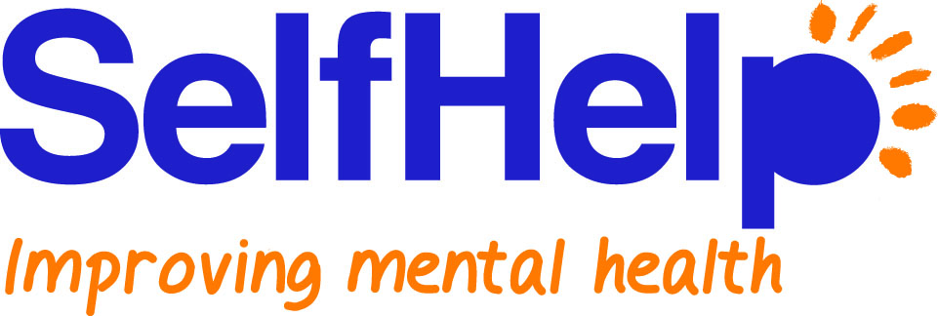

BOOST COURSE REQUEST FORM

PRIVATE & CONFIDENTIAL

Please note:
Please ensure you answer every question on this form with as much detail as possible to give us the best understanding of your interest in the course.

Contact Details

Name: …………………………………………………………………………………………………………………

Date of Birth: …………………… Male / Female: ………………..

Address: ……………………………………………………………………………………………………………………………….

…………………………………………………………………………………………………………………………………

Post Code: …………………......... Tel No. Home: ………………………………........

Mobile: …………………………………........

Email address:…………………………………………………………………………………………………………

Is it acceptable to you for us to leave a message:

(a) with someone answering your phone Yes⁭ or No ⁭
(b) on your answer machine Yes or ⁭ No ⁭

Do you have any physical health problem(s)?
Yes ◻ No ◻
If yes, please state: ________________________________________________

Do you have any mental health difficulties? For example, anxiety problems, depression etc.
Yes ◻ No ◻
If yes, please state: ________________________________________________

Why do you want to attend the Boost: Emotional Resilience Course?

Where did you hear about the Boost: Emotional Resilience Course?

If you would like to receive details of future health and wellbeing services delivered by Self Help Services please tick here

PLEASE RETURN THIS FORM TO:
SELF-HELP SERVICES,
Community Services, Oakland House, 76 Talbot Road, Manchester M16 0PQ

or email it to:
communityservices@selfhelpservices.org.uk

